الاسم : رنا السيد ابراهيم

سكشن : 3

Task1: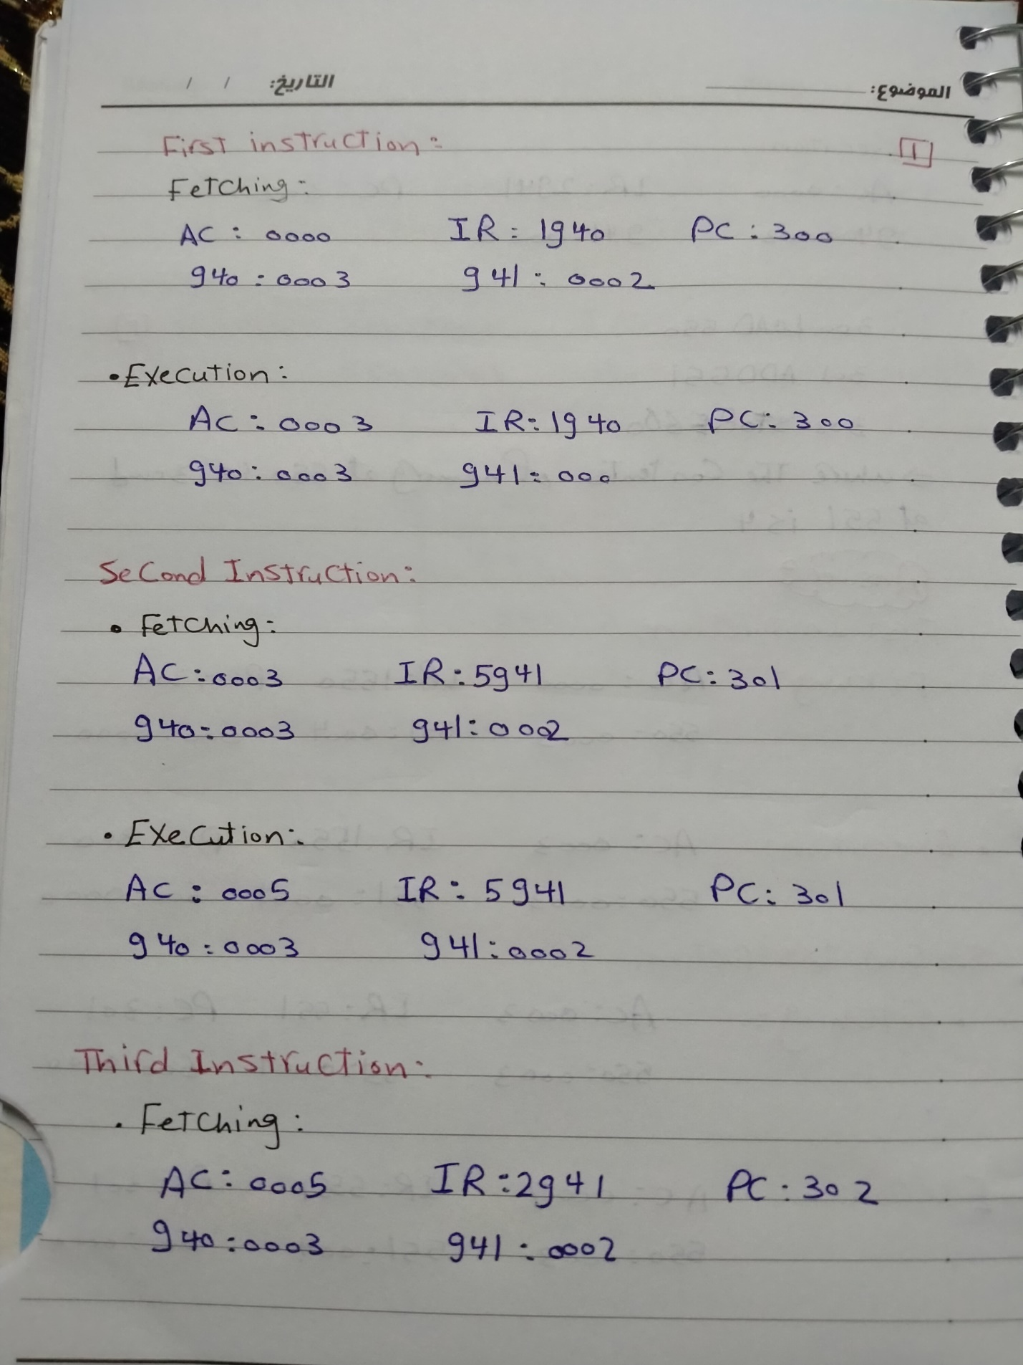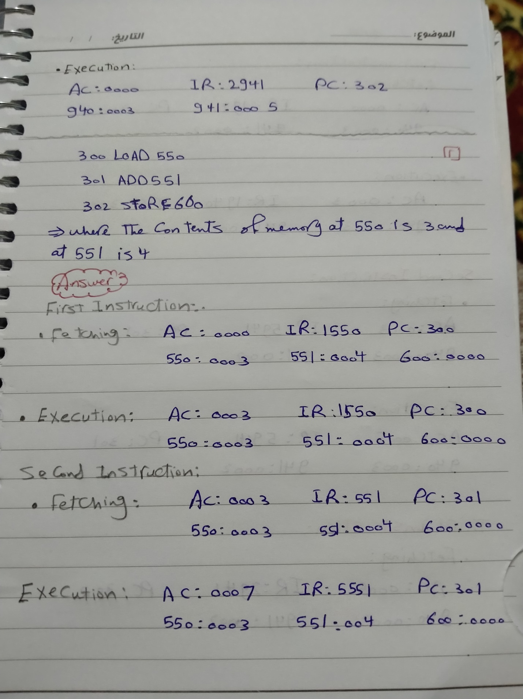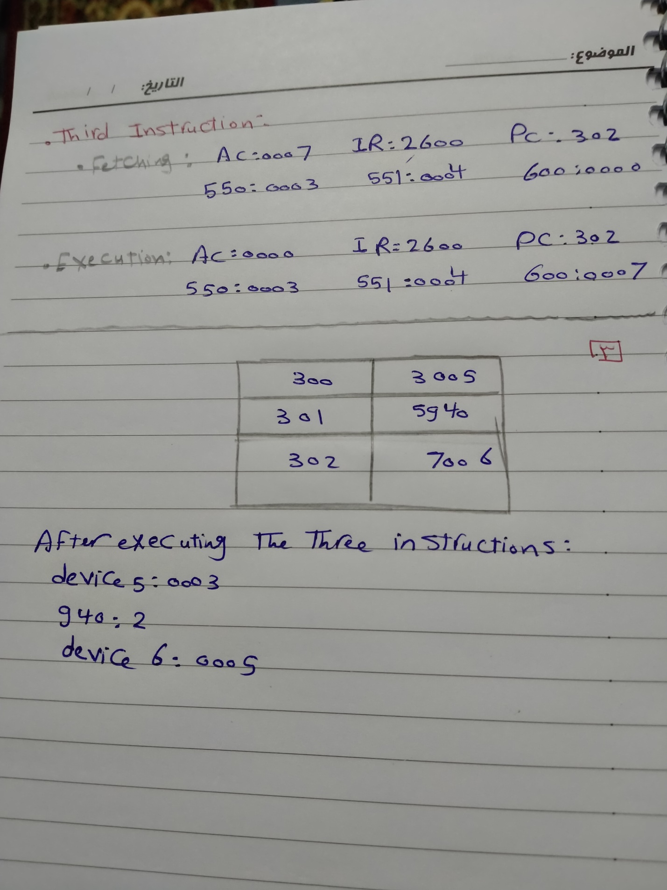

Task2:

**Q1: Calculate the time for each process, define the priority?**

**Answer :**

As an example of this approach, consider a system with threeI/O devices: a printer, a disk, and a communications line, with increasing priorities of 2, 4, and 5, respectively. A user program begins at t=0. At t=10, a printer interrupt occurs; user information is placed on the system stack and execution continues at the printer interrupt service routine (ISR).While this routine is still executing, at t=15, a communications interrupt occurs. Because the communications line has higher priority than the printer, the interrupt is honored. The printer ISR is interrupted, its state is pushed onto thestack, and execution continues at the communications ISR. While this routine is executing, a disk interrupt occurs (t=20). Because this interrupt is of lower priority, it is simply held, and the communications ISR runs to completion.-When the communications ISR is complete (t=25), the previous processor state is restored, which is the execution of the printer ISR. However, before even a single instruction in that routine can be executed, the processor honors the higher priority disk interrupt and control transfers to the disk ISR. Only when that routine is complete (t=35) is the printer ISR resumed. When that routine completes (t=40), control finally returns to the user program .

[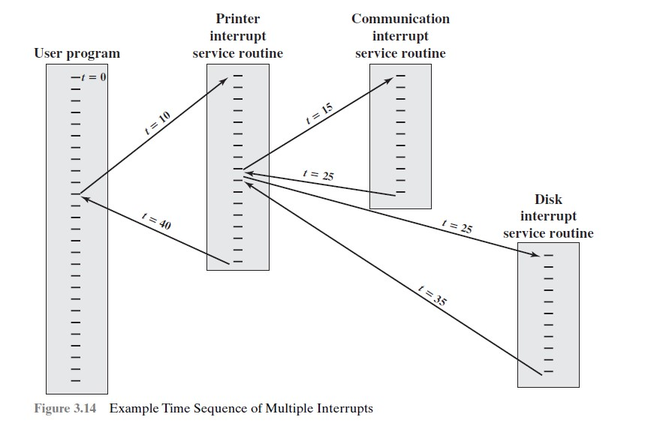](https://1.bp.blogspot.com/-IUM1llF10tg/WPm8V_G-gCI/AAAAAAAAEBs/i8JKSVQsQostgum0eiF92b4bFATMSxI6QCK4B/s1600/sequence-of-multiple-interrupts.jpg)

***Rana Alsaid Ibrahim***

***Sec:3***

____________________________________________________

Task3:

1_ List the access method on memory?

S:

* Sequential Access
* Direct Access
* Random Access
* Associative Access

_________________________________________________________

2_ Write notes about “word” on memory?

S:

A **word** is the natural unit of data used by a particular [processor](https://en.wikipedia.org/wiki/Central_processing_unit) design. A word is a fixed-sized [piece of data](https://en.wikipedia.org/wiki/Data_(computing)) handled as a unit by the [instruction set](https://en.wikipedia.org/wiki/Instruction_set) or the hardware of the processor.

A word size of 10 or 12 [decimal](https://en.wikipedia.org/wiki/Decimal) digits, and some early [decimal computers](https://en.wikipedia.org/wiki/Decimal_computer) had no fixed word length at all. Early binary systems tended to use word lengths that were some multiple of 6-bits, with the 36-bit word being especially common on [mainframe](https://en.wikipedia.org/wiki/Mainframe) computers. The introduction of [ASCII](https://en.wikipedia.org/wiki/ASCII) led to the move to systems with word lengths that were a multiple of 8-bits, with 16-bit machines being popular in the 1970s before the move to modern processors with 32 or 64 bits.[]](https://en.wikipedia.org/wiki/Word_(computer_architecture)#cite_note-Beebe_2017-1) Special-purpose designs like [digital signal processors](https://en.wikipedia.org/wiki/Digital_signal_processor), may have any word length from 4 to 80 bits

3_ Write notes about memory hierarchy?

S:

The memory in a computer can be divided into five hierarchies based on the speed as well as use. The processor can move from one level to another based on its requirements. The five hierarchies in the memory are registers, cache, main memory, magnetic discs, and magnetic tapes. The first three hierarchies are volatile memories which mean when there is no power, and then automatically they lose their stored data. Whereas the last two hierarchies are not volatile which means they store the data permanently.

_____________________________________________________________________________________

Task4:

**Q1: Write notes about the types of ROM ?**

S:

* **MROM : Mask Read Only Memory**

### EPROM : Erasable Programmable Read Only Memory

### EEPROM : Electrically Erasable and Programmable Read Only Memory

_________________________________________________

**Q2: The main difference between RAM and ROM is ….**

* **Read / Write**
* **Read Only**
* **No Read / Write**
* **None of the above.**

___________________________________________________

**Q3: The size of Memory is depending on**

* **Address lines**
* **Data lines**
* **OR gates**
* **Address lines and Data lines**

**Q4: True or False**

1. 1 bit = 8bytes (F)
2. 16-byte word = 4 bytes (F)
3. 32-bit word = 4 bytes (T)
4. RAM is able to provide READ/ Write (T)
5. ROM is programmed and the data is stored based on hexadecimal system (F)
6. G(giga) 2^20 , it means the number of address lines is 20 (F)
7. 64K = 2^16 , the address lines is 64 (T)

________________________________________________